Bradford Wheelchair Services

Welcome Booklet

Welcome to Bradford Wheelchair Services
What do we do?
Where to find us
Our mission
NHS criteria
Meet the team
Who do we work with?
What will happen?
Powerchairs
Children’s growth
Our approved suppliers
Personal wheelchair budgets (PBWs)
Review and repair
Equipment hire
Complaints and compliments
Community resources and local authority contacts

What do we do?
We are a service who assess and decide which type of wheelchair or mobility a person will be entitled to on the NHS. We provide services to people of all ages and assess patients in clinics, at local schools and in the community. We run numerous clinics, including special seating and therapy, and offer environmental visits and home appointments where appropriate.

Where to find us:
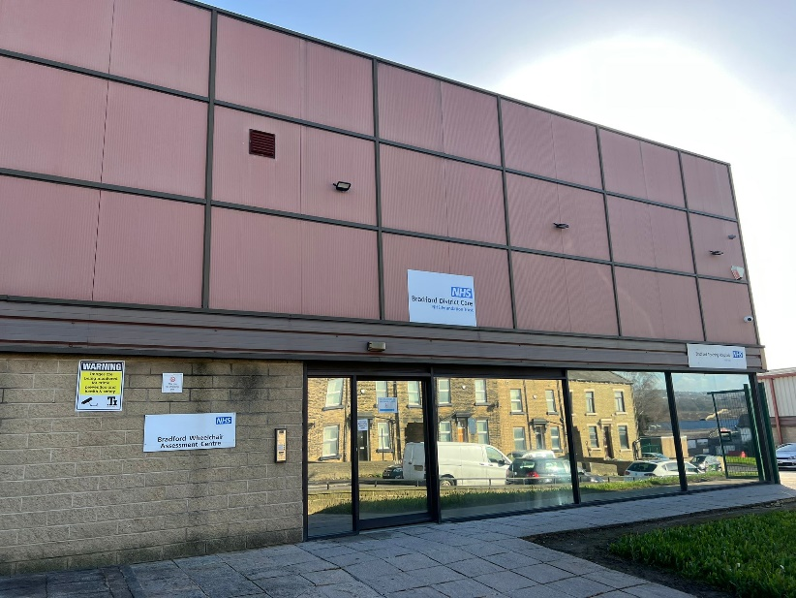
We are open Monday to Friday 0800 to 1600 hours and are located at the following address:
Bradford Wheelchair Services
Unit 1
Four Lanes Business Park
Cemetery Road
BD8 9RY

Our telephone number is:
01274 322555

Our Mission – Wheelchair Charter
- An NHS commissioned service committed to:
- Equity of access and provision for all, irrespective of age or postcode.
- A working partnership with wheelchair users and their family/carers, including with design, innovation, and service change.

- Referrals:
- From an appropriately skilled professional.
- Undertaking assessment and wheelchair provision within the NHS constitutional right of 18 weeks.

- Assessment:
- Wheelchair and postural support assessment should consider all aspects of individual current and future needs, including those of carers, with a prescription maximising independence, health, and well-being.
- Clinicians will work with appropriate services to achieve goals agreed between the wheelchair user, carers, and wheelchair provider. This includes access to home, school, work, and leisure activities.

- Equipment:
- Delivered, maintained, and regularly reviewed as per need.
- Individual reviews based on recognised outcome measures.
- The service delivered across geographical boundaries where needed.

- Funding:
- NHS will fund the chair to meet postural and mobility need.
- Opportunities will be sought to access flexible and innovative budgeting, including Personal Wheelchair Budgets. Should the service user want to add extra features to a wheelchair.
- Collaboration with different services and alternate funders to facilitate agreed outcomes.

- Staffing:
- The specialist professionals will be appropriately qualified and will receive on-going training and development.
- Will have a broad knowledge of wheelchair and postural support options.
- Work with manufacturers and independent organisations to develop innovative and affordable products for the future.

NHS Criteria for Wheelchair assessment

Referrals can be made to Bradford Wheelchair services for a wheelchair assessment when a service user meets to following criteria:

Registered with a GP withing the Bradford district.

Lawfully entitled to reside in the UK and receive NHS treatment in their own home (secondary care).

The person must have an identified long term medical condition or palliative care need requiring a wheelchair.

The person must also have a long-term mobility problem and be classified as unable to, or virtually unable to walk indoors or outdoors. Long term is more than 6 months.

Wheelchair Services DO NOT PROVIDE

For short term use (less than 6 months)

Wheelchairs used instead or armchairs or dining room chairs (static seating)

Attendant pushed wheelchairs for general use by multiple people in a care or nursing home

Wheelchairs for portering purposes for example transferring residents from room to room in a care or nursing home.

Powered outdoor only wheelchairs

Mobility scooters

Wheelchairs specifically for work, education or sporting requirements

Powered packs or powered wheels that are retrofitted to manual wheelchairs

Seat raisers in powered wheelchairs

Sunshades/canopies for buggies unless required for specific medical need

Trays unless required for postural support or independence as identified by wheelchair service on assessment.

Transportation clamps for transportation purposes

Buggies for children who can be accommodated in a standard retail buggy unless supportive seating is essential.

The assessing clinician will identify the mobility and postural needs with the service user and their carers before deciding the most suitable provision.

Meet the team
During your time at Bradford Wheelchair Services, you will meet or come across different members of our team, all of which have different roles. These roles include:
Specialist Rehabilitation Engineer
Physiotherapist
Occupational Therapist
Assistant Practitioner
Administration Support Staff

Who do we work with?
Healthcare professionals
Parents and carers
Schools
Social workers
Suppliers of Wheelchairs
Tissue Viability Nurses (TVN)
Orthotist and Prosthetist

What will happen?
Dependent on referral and triage you may have a standard wheelchair sent straight to your home. However, should the referral be for a child or needs to be more bespoke you will need to be seen by a member of the team.
Our clinic room is equipped with a ceiling track hoist, standing aids and slide boards. Please ensure you attend with your own sling or transfer equipment where possible.

Where might you be seen?
- The wheelchair and special seating service currently operates at Bradford Wheelchair Services.
- Appointments may take place at the clinic or the place you reside most at where appropriate, e.g., your home, or at your school. You may be visited at home if you are unable to travel for medical reasons due to a condition, or if the assessment requires you to be in your home environment.

Who might see you?
- A therapist and / or rehabilitation engineer, wheelchair assistant or technician as appropriate from the referral.
- Other healthcare professionals may also be invited to attend as appropriate.
You can choose to have a family member, carer, or friend present at the assessment.

The assessment appointment:
- You will be allocated a 30-60 minute appointment.
- At the assessment stage, a functional and postural assessment will be undertaken.
- Your goals and expected outcomes for mobility will be discussed.
- Equipment may be trialled, and options discussed, taking into account your clinical and functional needs and your goals.

Following the assessment:
- Order of equipment if appropriate.
- Personal wheelchair budget taken if appropriate.
- Further appointment if necessary to trial or assess with equipment that needs to be obtained from manufacturers.

Powerchairs
If you are being assessed for a powered chair, there are various stages of the assessment:

- GP to complete referral and confirm of medical eligibility.
- Environmental and physical assessment, completed at the home address.
- Sight test form completed by optician.
- Driving safety assessment indoors.
- Road safety test to permit outdoor use.

Once we have confirmed you can use your chair in and/or out of your home safely, your chair will be issued.

Important notes regarding powerchairs:

- Powered wheelchairs can be supplied either for indoor use only, or for indoor and outdoor use. In both cases a detailed assessment is required. Our service does not supply powered wheelchairs to be used outdoors only. Power chair must be able to go around your home.
- To qualify for a powerchair, you must be free from conditions causing loss of consciousness and epileptic seizures in waking hours within the past year. You must also not be on medication that can affect your driving.

Wheelchair prescription:
Following your assessment, we will explain the best options to meet your clinical needs and then begin the process of getting your chair.

Wheelchair handover:
We will decide how best to handover your new equipment and seating. This could be with the therapist and rehabilitation engineer, or by our approved repair technicians. In all cases, we will conduct a thorough handover of your equipment explaining it fully and adjusting it to suit your specific needs. Your handover will include a demonstration of how:

  - The wheelchair folds and unfolds.
  - The footrest is attached/detached to the chair.
  - To remove and replace the armrest for transfer.
  - A power chair is recharged and how often it requires charging.
  - A lap strap works and is adjusted.
You are borrowing the equipment from us and must look after it according to our terms and conditions.

Children’s growth
Children grow at a rapid rate, and so it is important that we supply a chair to accommodate this. This is particularly important for those with long term degenerative conditions, whose equipment must allow for growth and specific postural needs.
More appointments may be needed due to this, so please ensure you are staying in regular contact with the service.

Our approved suppliers
We work with our suppliers to ensure we offer the best chairs available through the NHS.

What might they look like?
Self-propelled wheelchair | 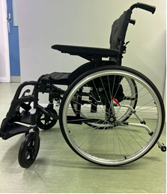
Transit | 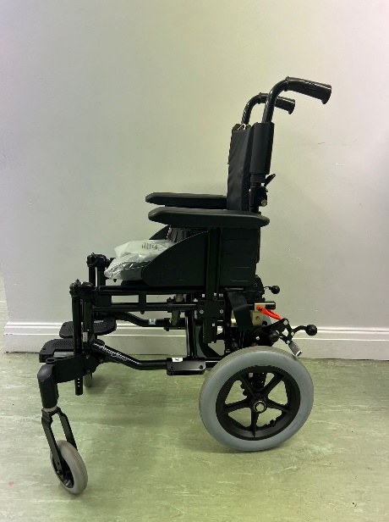
Special seating | 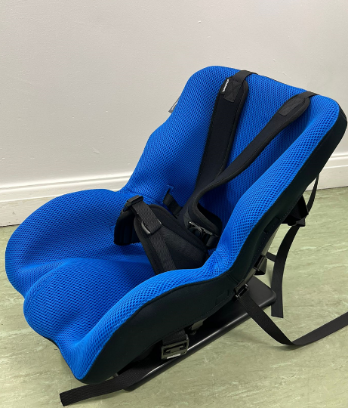  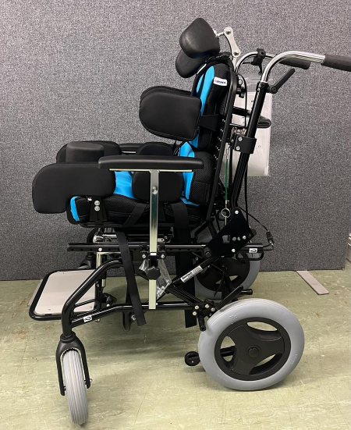
Buggie | 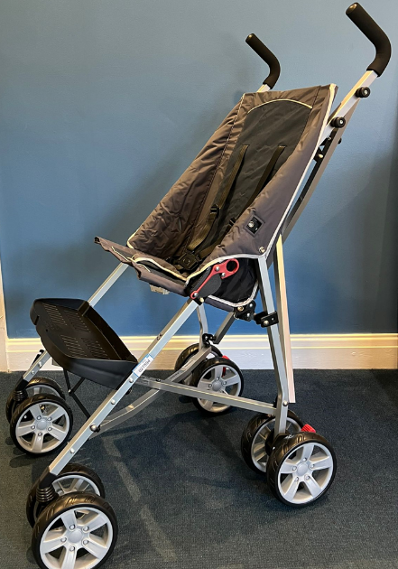
Powerchair | 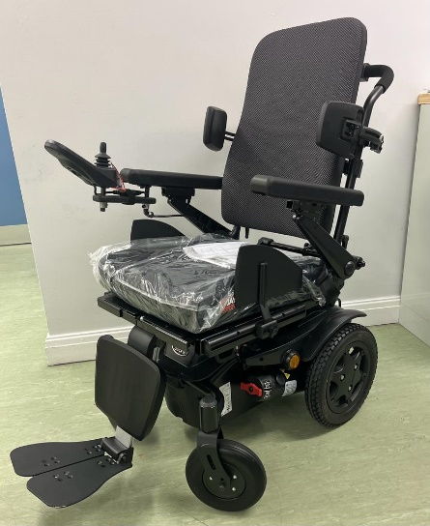

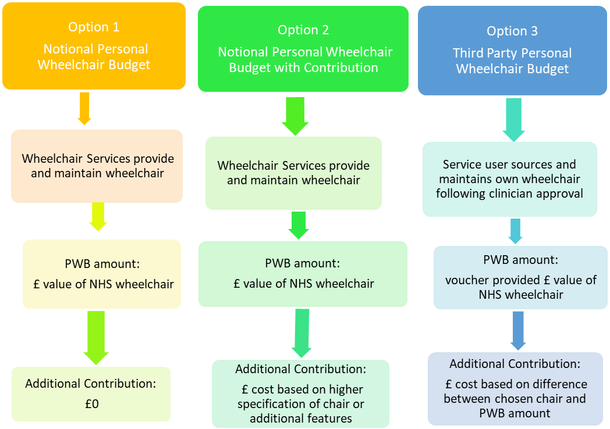
Personal Wheelchair Budgets (PWBs)

If you need a wheelchair, you can have one that meets your mobility needs free of charge from the NHS. However, if you prefer a different wheelchair that the NHS cannot provide, you may be entitled to a contribution towards its cost instead. The wheelchair service will still need to ensure that the wheelchair you choose is safe for you and meets all your clinical needs.

There are 3 types of Personal Wheelchair Budget:
Notional personal: is an NHS prescription from our comprehensive equipment range and will not cost you anything. Equipment is provided on a loan free of charge and remains the property of the NHS. We provide repairs and maintenance. You are eligible for reassessment if your clinical needs change.
Notional personal with contribution: is when you add accessories or upgrade but still within our NHS equipment range. The NHS funds the basic provision but you or someone else contributes the cost of the upgrade or accessory. This can be specific tyres or a battery pack to a manual wheelchair, adding a seat riser to a powered wheelchair for example. Equipment belongs to the NHS, and we will maintain and repair it, but you are responsible for maintaining accessories you purchased. You are eligible for reassessment if your clinical needs change.
Third party: is opting out of NHS supply and using the virtual cash to buy your own wheelchair privately from an approved supplier. The PWB is the cost of the standard NHS prescription and must be used on the same category of equipment to meet the prescription. For example, a manual PWB cannot be used for a powered wheelchair. You are responsible for repair and maintenance and ensuring it remains clinically suitable for the period. You will be reassessed within the term only if your clinical needs change from your primary medical condition.

A PWB discussion and personal support plan is triggered when a new service user requires their first wheelchair, or an existing wheelchair needs replacing.

There are some exceptions. We will not offer a PWB when:

● It is first provision and clinical needs are predicted to change within 6-12 months (e.g., a stroke or degenerative conditions)
● Urgent provision for discharge, palliative and some care or nursing home scenarios
● The service user wants a change but there is no clinical indication for prescription change and the existing wheelchair still meets their clinical needs safely
● Reviewing accessories, special seating and posture needs will not trigger a PWB – only the wheelchair base or wheelchair being changed would
● We consider our full repair and maintenance service is needed for safety

Repair and maintenance
This is completed by the Bradford District Care Foundation Trust. Should you need a repair please call our reception and a repair will be booked for you.

Equipment hire
If you would like to hire a wheelchair for occasional use, these are some local suppliers…
Red cross at £22: https://www.redcross.org.uk/get-help/hire-a-wheelchair

Community resources and local authority contacts
Technology Enabled Care (TEC) in the Bradford district: the local authority can provide pieces of equipment to support mobility in your home, and adaptations, such as ramps, door widening, hoists, bathroom facilities etc., can be made with the help of a Disabled Facilities Grant. For more details, please visit https://www.bradford.gov.uk/adult-social-care/living-independently/equipment-and-adaptations/

Bradford and Airedale Community Equipment Service (BACES) can provide you with a wide range of equipment to help you live more independently, e.g., support with bathing, showering and toileting, or household and kitchen tasks. For more information, please visit https://www.bradford.gov.uk/adult-social-care/living-independently/bradford-and-airedale-community-equipment-service/
Motability who offers a range of cars, Wheelchair Accessible Vehicles (WAVs), scooters and powered wheelchairs that you can choose from. For more information, please visit https://www.motability.co.uk/
William Merrit Centre the Centre carries out assessments for members of the public to help them choose and use daily living aids with confidence and enhance their independence. All assessments are impartial, and we offer advice on equipment and where to buy it.
https://wmdlc.org/

Complaints and compliments
Our Patient Experience Team is here to listen and respond to your experiences and help us improve your care and our services in the future. We provide a compassionate, proactive, and responsive support service for our patients, relatives and carers. Our role is to listen to all feedback whether this is a compliment, concern, complaint or simply a request for information. We are here to help you.
We value your opinions and recognise the importance of your experiences. We appreciate that sometimes we make mistakes. Your feedback is very valuable and will help us to improve our services. We know that things don’t always go as expected, so in the first instance please speak to the Service Manager who will make every effort to help you and resolve your concern so that we can quickly put things right.

Bradford Teaching Hospital Foundation Trust
Clinical and assessment Patient experience: 01274 364810 Or patient.experience@bthft.nhs.uk

Bradford District Foundation Care Trust
Repair and maintenance PALS: 01274 251440 Or advice.complaints@bdct.nhs.uk

