

Neonatal Ventilation – basics of mechanical ventilation

Authors: Sam Wallis - Catriona Firth

Approved by: –Neonatal Guidelines Group 04/03/2014. No change 2017 – Reviewed Sept 2019.

24/8/2023 – guideline currently under review

Review date: 1/6/2024

Version: 4

**Mechanical Ventilation in Neonates**

**Introduction**

Additional respiratory support is required when babies are unable to achieve satisfactory gas exchange by themselves. Whilst we now commonly use non-invasive techniques (CPAP / Hi-flow), a good understanding of how and when to use mechanical ventilation is a key part of neonatal practice.

Although most of our babies require ventilating because of lung problems related to prematurity, we also see a number of pathologies that require very different strategies. For example, meconium aspiration, PPHN, or infants with normal lungs who require ventilation for other reasons (such as hypoxic brain injury or a neuromuscular disorder).The following is therefore intended as an introduction to the basics and an initial guide. It is not a protocol. There are no magic ventilator settings that work in all situations and you will find practice varies between individuals.

**Related guidelines**

* *BEaCoN – early care of the newborn*
* *Surfactant Therapy*
* *PPHN*
* *Saturation monitoring on the neonatal unit*
* *Endotracheal Intubation*

**NICE guidance – Specialist Respiratory care for babies born preterm** [**https://www.nice.org.uk/guidance/ng124**](https://www.nice.org.uk/guidance/ng124)

**Contents**

1. Basic principles of ventilation
2. The Drager ventilator
3. Modes of ventilation
4. Suggested Settings
5. Blood gas interpretation
6. Changing ventilation settings
7. Weaning and extubation
8. Trouble shooting
   1. Deterioration on the ventilator
   2. Optimising mechanics
   3. Alarms
9. HFOV
   1. Oxygenation index calculator
10. **Basic** **Principles**

**Indication for intubation / ventilation**

*For early care of preterm infants – see BEaCoN guidance*

This decision should be discussed with your senior but we may intubate and ventilate in the following circumstances

|  |
| --- |
| **1. Apnoea/bradycardia (recurrent)** |
| **2. Respiratory failure (clinical)** |
| **3. Deteriorating blood gases** |

**Oxygenation / Ventilation**

The goal of ventilation is to achieve satisfactory Oxygenation and Ventilation.

Oxygenation (**PaO2**) is determined by the Inspired oxygen fraction (**FiO2**) and Mean airway pressure (**MAP**).

Ventilation (**CO2**clearance) is determined by the Minute Volume (**MV**= Tidal Volume (**VT**) x Rate (**R**)).

The mechanical ventilators used on NNU allow us to control both oxygenation and ventilation by adjusting the parameters outlined below.

Look at the simplified Pressure / Time curve, a version of this can be seen on the ventilator screens on the unit

This illustrates what respiratory support is being delivered to the baby

PEEP

P

Time

PIP / Pinsp

Ti

**Inflation pressure** – will determine **VT**

Te

PIP or Pinsp = Peak inspiratory pressure (pressure delivered during inspiration)

PEEP = Positive end expiratory pressure (“baseline” pressure maintained during expiration)

Ti = Inspiratory time

Te = Expiratory time

Ti + Te = 1 respiratory cycle (number of cycle / minute = Rate). Reducing Te increases rate.

VT = Tidal volume – the volume of gas moved with each breath (the difference in PIP and PEEP will determine the VT delivered)

**Oxygenation**

Positive pressure opens up the lung and (with an oxygen containing gas) allows oxygenation of the alveoli.

The Mean Airway Pressure is the combination of PIP and PEEP – represented by the shaded area under the pressure / time curve.

Increasing either PIP or PEEP will increase this area and therefore oxygenation. The way this is done depends on the mode selected (see Modes below).

Increasing Ti also increases this area under the curve and can be used to improve oxygenation in some circumstances.

**Ventilation**

Movement of gas in and out of the lung allows CO2 to be excreted.

CO2 clearance increases (and therefore PaCO2 falls) with an increase in Minute Volume (the volume of gas moved in and out of the lungs every minute).

As Minute Volume is a product of Respiratory rate and Tidal Volume (gas moved with each breath), increasing either of these should increase CO2 clearance.



Increasing Rate is easy on modern ventilators. As the Ti is set separately, the machine alters rate by automatically changing the expiratory time (Te) according to the number of breaths / minute you select.

Increasing Tidal Volume is achieved by increasing PIP (or much less commonly by decreasing PEEP). The machine will do this for you in Volume Guarantee mode (see below) but needs to be done manually in Pressure limited modes.

|  |  |
| --- | --- |
| **Increase oxygenation** | Increase FiO2  Increase MAP(PIP +/-PEEP) |
| **Increase ventilation**  **(= decreasePaCO2)** | Increase VT  Increase Rate |

Deciding which parameter to change takes practice. As you can appreciate, certain alterations will affect both Oxygenation and CO2 clearance – increasing PIP for example (either directly or by altering VT settings) will increase Oxygenation and CO2 clearance.

To use the ventilator safely, you will need to be able to anticipate the effect of these changes.

1. **Drager Ventilators**

**VN 500**

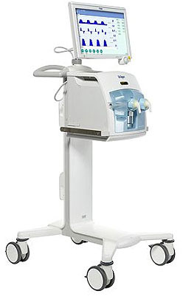We use the Drager Babylog VN500 ventilator with Infinity C500 touchscreen display.

The ventilator receives piped oxygen and air from the wall.

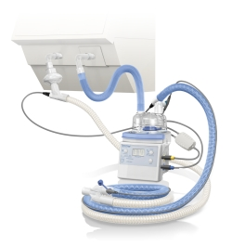A Fisher-Paykel breathing circuit is attached to the front.

The inspiratory blue hose is passed through a humidifier to make sure warmed, moist gas is delivered to the baby.

The white hose is the expiratory limb which passes gas back to the machine. The circuit needs to have low compliance so as much of the delivered volume gets to the baby as possible

A flow sensor is attached between the circuit and the end of the ET tube.

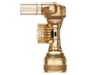This is a crucial piece of kit which feeds back flow and volume information to the ventilator. It is calibrated before

use and needs to be kept free of moisture

The ventilator is fairly easy and intuitive to use. A vast amount of information is available within the ventilator itself – take some time to look at the displays and familiarise yourself with how to change functions.

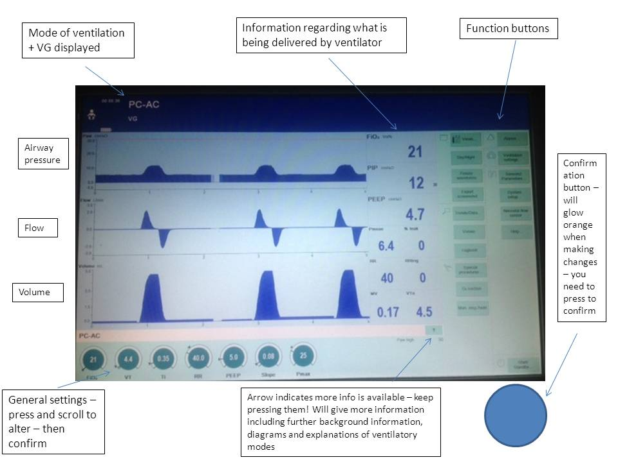

1. **Modes of Ventilation**

As with all modern ventilators there are lots of ways it can be set up to deliver respiratory support. This can be confusing but the basic principles remain the same and in practice we actually only use 2 or 3 different modes.

**Terminology**

**Synchronisation**

Most of our babies are not paralysed with muscle relaxants. As such they can make their own breathing effort whilst being mechanically ventilated.

All our commonly used modes are therefore “synchronised” – the ventilator tries to co-ordinate mechanically delivered breaths with the baby’s own spontaneous respiratory effort.

The ventilator does this by allowing a baby the chance to initiate a breath within a certain time window.

Baby’s spontaneous breathing efforts are detected by small changes in flow across the flow sensor. The sensitivity of the flow sensor can be adjusted (flow trigger) if necessary. Sometimes fluid in the breathing circuit can mimic the flow changes of a spontaneously breathing baby – this is called *auto-trigger* (see below)

**Pressure vs Volume guided (VG)**

Ventilators keep lungs inflated by applying positive pressure. The continuous background pressure is known as PEEP and is important to stop lungs collapsing. Intermittently the ventilator will increase the pressure (PIP or Pinsp) to drive air into the lungs and deliver a breath.

The pressure the ventilator delivers is selected by you. Historically this was done by simply dialling in a Pinsp (cm H20). This is fine but the amount of gas (tidal volume – VT) actually delivered is not just dependent on pressure – it is also determined by the compliance of the lung you are ventilating. A stiff lung will inflate less than a compliant lung for the same applied pressure.

This is important for a number of reasons

* Gas exchange is determined by the tidal volume.
* Lung compliance can change over time (rapidly in the case of preterm infants receiving surfactant) therefore a selected PIP will deliver different tidal volumes at different times.
* Lungs are damaged by mechanical ventilation. Over distension from excessive tidal volumes (volutrauma) is one of the chief mechanisms by which this occurs.

Modern ventilators now allow you to select the tidal volume you want to deliver – by adding **“Volume Guarantee”** to your set mode. Usually this is set between **4-5ml/kg**.

The ventilator will then automatically alter the PIP (below a maximum limit) to deliver a consistent tidal volume regardless of changes in compliance. Theoretically this reduces the risk of overdistension, particularly in newborn preterm infants.

Use of VG / Volume Guarantee is increasingly popular and, for many neonatologists, the default option. However it is not always the right choice – **it relies on accurate measurement by the flow sensor and does not work well where there is a large leak (>50%) around the ET tube.**

|  |  |
| --- | --- |
| **Pressure limited** | Set Peak pressure  Variable Tidal Volume |
| **Volume Guarantee** | Set Tidal Volume  Variable Peak Pressure |

**Modes (con)**

Don’t worry too much about the following acronyms – they are designed to confuse and vary with manufacturer.

**PC-AC** (SIPPV in old money) or **SIMV** are our standard modes.

**PC-AC** means *all* breaths (ventilator and baby initiated) are supported by the ventilator. The baby therefore does not have to do the extra work of drawing in air through a ventilator circuit and ET tube. Of note - for babies breathing above the back-up rate, weaning ventilation by reducing the rate will have no effect.

**SIMV** means only the set rate back-up breaths are supported. This allows greater control in terms of weaning but means spontaneously breathing babies have to expend greater energy breathing at faster rates.

Both modes are synchronised and both can have **Volume Guarantee**.

Just to confuse you there is also an option to add additional  **P support** in **SIMV** mode. This can be viewed as a “half way house” between SIMV and PC-AC. Ventilator breaths are supported at the selected PIP, however additional, patient initiated breaths above the back-up rate are given some extra support (at whatever delta-P you select above PEEP). The idea is that the ventilator can help the baby overcome the resistance of spontaneously breathing through an ET tube / circuit without needing to give a “full” ventilator breath each time. We don’t use this often.

It is better to use a mode you are familiar with rather than trying to be too clever.

|  |  |  |  |  |
| --- | --- | --- | --- | --- |
| **Mode** | | **Explanation** | **Pro and Cons** | **Use** |
| **PC-AC**  **(Pressure Control-Assist Control)**  ***AKA Synchronised intermittent positive pressure ventilation (SIPPV)*** | Every breath taken is assisted.  At a set rate of 50, the ventilator will deliver 50 breaths synchronised with the baby’s own respiratory effort.  If the baby is breathing above the set rate, each additional breath is also supported.  So, if the baby is breathing at a rate of 100, the additional 50 breaths above the back-up rate will also be supported by the ventilator to the set PIP or TV | | All breaths supported  No breathing against/through ETT which can cause tiring  Can be difficult to achieve synchronisation with high respiratory rates | Mode of choice, particularly for pre-term babies.  Lower rate (ie 30-40) can be used with good respiratory effort.  Remember intubation drugs reduce baby’s own effort – may need to increase rate at this time. |
| **PC-SIMV**  **(Pressure Control-Synchronised intermittent mandatory ventilation)** | The set rate is delivered to the baby, synchronised with the baby’s own respiratory effort.  If the baby is breathing above the set rate, these additional breaths are not assisted by the ventilator.  So, if the baby is breathing at a rate of 60, on a set rate of 40, 40 of the breaths will be delivered to the set PIP or TV and the additional 20 breaths are unassisted. | | Baby makes own effort  Can be useful if over-ventilating  Can be useful for weaning  Preterm/small babies tire if breathing through ETT unassisted | Can be useful in term babies with good respiratory effort, or where there are concerns regarding over-ventilation  Consider use of Delta-P support in preterm babies (gives partial support - ie to set level above PEEP). |
| **PC-PSV**  **(Pressure control - Pressure Support Ventilation)** | All breaths are assisted with a set back-up rate, similar to PC-AC.  However, the inspiratory time is limited according to the baby’s own lung inflation (ie as the lungs fill up the breath is terminated). The patient thus determines the number of breaths above the set rate, when the breaths occur, *and their duration*. The ventilator supports these breaths to a set PIP or TV. | | Durations of breaths controlled according to lung mechanics  Reduced air trapping | Can be helpful in babies with CLD where air-trapping is thought to be a problem |

1. **Suggested Settings**

**Ventilation settings should be individualised to the needs of the baby**

This is a **very** rough guide when starting ventilation in a non-muscle relaxed baby

***Preterm infant with RDS***

PC-AC with VG 🡪 Rate 40-50, Ti 0.3, PEEP 5, VT 4ml/kg (Pmax 28)

*Avoid Hypocarbia. (pCO2 <4.5)*

*Early gas (within 1st hour) and alteration of VT accordingly.*

***Term infant with primary lung disease***

PC-AC +/- VG 🡪 Rate 50, Ti 0.4-0.45, PEEP 5-6, PIP to achieve VT of 4-5ml/kg

*Consider HFOV if requiring high pressures (PIP >28-30)*

*Also see PPHN guidelines*

***Minute volume alarm***– limits should be set on starting ventilation – **0.15 - 0.35ml/kg.** This will give you some warning in the event of the ventilator delivering very low or very high tidal volume. If the alarm is sounding then don’t just silence it – check the baby and check a blood gas

***Flow sensor alarm*** *–* The flow sensor may need calibration – it needs to be working effectively to allow synchronisation and measurement of tidal volume - follow the onscreen instructions to recalibrate.

If the flow sensor is misbehaving then it may be safer to use a standard pressure mode (e.g. PC-AC) rather than VG - see Alarms.

In all cases it is important to look at what the ventilator is delivering and how the baby is responding. You may need to alter things immediately.

A gas should be done early (30-60mins within commencing ventilation) and alterations made accordingly.

**A note on NICE Guidance -** [**https://www.nice.org.uk/guidance/ng124**](https://www.nice.org.uk/guidance/ng124)

NICE have recently published guidance (Specialist Neonatal Respiratory Care for Babies Born Preterm NG124) which gives some advice regarding invasive ventilation. It is largely in keeping with the advice above, and recommends use of VG in preterm babies.

When VG is not effective, NICE (and we!) suggest considering HFOV. Decisions to use HFOV should be made at consultant level. This mode of ventilation is discussed in more detail below.

Where VG or HFOV are not suitable, NICE suggests using SIMV in conjunction with pressure limited ventilation. They advise against using “synchronised pressure-limited ventilation such as assist control (AC), synchronised intermittent positive pressure ventilation (SIPPV), patient triggered ventilation (PTV), pressure support ventilation (PSV) or synchronised time-cycled pressure-limited ventilation (STCPLV).”

The assumption is that in PC-AC more breaths at higher pressures will be given, and it is these higher pressure breaths that are damaging to the lungs. Therefore by giving pressure limited ventilation with SIMV, there is more control over the number of high pressure breaths being given, and potentially less damage to the lungs. In reality, unless the baby is breathing at a rate considerably higher than the set rate, there may not be much difference between SIMV and PC-AC. NICE is clearly evidence-based, but the evidence in this area is muddied somewhat by use of a large number of difference acronyms, which may or may not describe the same or very similar things, as well at the use of a network meta-analysis where comparisons have been made using groups of babies from different studies, rather than direct comparison.

So, on occasions where pressure limited rather than volume limited ventilation is used for preterm babies, we do not necessarily suggest using SIMV rather than PC-AC as the default mode, as there should still be some thought behind whether the baby will tire. What we do recommend, is careful consideration of the mode of choice according to the rate at which the baby is breathing, an early gas, and adjustment of ventilator settings accordingly. i.e as stated above:

**Ventilation settings should be individualised to the needs of the baby.**

**Blood gas interpretation**

Target blood gas and oxygen saturation values

|  |  |
| --- | --- |
| **Oxygen saturations**  >37/40 target 95% and above  <37/40 target 91-95% | Set FiO2 and Ventilator to achieve saturations as per unit policy |
| **pH**  7.25 – 7.35  (acceptable) | Although pH < 7.35 is strictly “abnormal” lower pHs are accepted to prevent over ventilation. |
| **pCO2**  4.5 – 6.5  PaCO2 < 4.5 should be avoided  PaCO2< 3.5 requires urgent attention | Relative hypercapnia is permissible to avoid over-ventilation and associated problems with lung injury and cerebral blood flow.  Higher PaCO2 levels are also acceptable in compensated respiratory acidosis. |
| **BE**  -4 to 4 | Metabolic acidosis with base excess of > -10 often requires action to normalise pH  Treating smaller deficits depends on clinical context.  It is important not to just treat a number – consider the cause (hypovolaemia, sepsis, bicarbonate loss)  Check urine output, BP, blood results, glucose – discuss with senior. |

Blood gases should be from an arterial or capillary sample.

* + pH is determined by respiratory and metabolic components - look at both when interpreting pH values.
  + It is not possible to interpret pO2 levels on a capillary sample.
  + Venous samples are not reliable for adjusting ventilation settings

Do not act on blood gas values alone. Before altering settings check:

1. Do the values fit with the clinical picture?

If not why not? Was it taken from a poorly perfused foot? Was there an air bubble? Is it venous?

1. Assess the baby

Is the chest moving? Is there air entry? Is the baby struggling on the ventilator? Are they tachypnoeic or apnoeic?

1. Look at the ventilator

Is it giving the settings you think it is? Look at the Minute Volume trend. Look at the Tidal Volumes and Leak. Is it set up properly? Is there a problem with the flow sensor?

1. Look at the charts and ask the nursing staff.

Has the baby been stable over the previous few hours? Are there a lot of secretions? Has the baby just been suctioned? Is the baby handling ok?

1. **Changing Ventilation Settings**

|  |  |  |
| --- | --- | --- |
| **Problem** | **Solution** | **Comment** |
| **Low oxygenation**  **Low saturations** | Increase the FiO2  Increase the MAP  (commonest solution in bold) | Easy Solution  Remember to assess the baby and consider CXR if O2 increased by >10-20%  **Increase PIP or VT (if VG mode)– may also affect ventilation (CO2 clearance)**  Increase Ti - but makes sure shorter than Te  Increase PEEP – particularly if pulmonary haemorrhage / struggling with stiff lungs |
| **High oxygenation**  **High saturations** | Decrease the FiO2  Decrease the MAP | Easy Solution  **Decrease PIP or TV – may also affect ventilation (CO2 clearance)**  Decrease the PEEP – if set at >5 and reason for higher PEEP resolved  Decrease Ti if it is too long |
| **Over-ventilation**  **High pH with low pCO2** | Decrease the VT  (do this first if the baby has good chest movement +/- high TV or MV)  Decrease the rate  Extubate baby | Decrease VT (VG mode) or the PIP  Avoid pCO2 <4.5  Decreasing rate is pointless if using PC-AC and baby breathing above set rate  Check sedation / need for caffeine  If not ready for extubation then consider switching PC-AC to SIMV |
| **Under-ventilation**  **Low pH with high pCO2** | Increase the VT  (esp if baby has little chest movement or low VT/ MV)  Increase the rate | Increase VT (VG mode) or the PIP  Reassess the baby if needing significantly higher pressures – why?  Usually by a step of 5  Important to consider mode of ventilation |

Increments

PIP changes – usually by 2 / change

Rate changes – usually by 5 / change

It is important to consider balance of changes i.e. if needing very high FiO2 but on low pressures it may be sensible to increase PIP, or if on high pressures but low rate may be sensible to increase rate.

If a blood gas is very abnormal or the settings are changed significantly, it is sensible to re-check the blood gas **30 minutes** after altering the settings.

If there are only borderline abnormalities or the settings are only “tweaked”, it can be ok to wait longer before re-checking the blood gas – look to see if there have been significant changes in **MV** as a result of your alteration.

1. **Weaning and Extubation**

Ventilation can be weaned according to blood gases and saturations as in table above.

Remember, weaning the rate is pointless in PC-AC mode if the baby is breathing spontaneously above the back-up rate.

In VG mode, “auto-weaning” of pressure should gradually occur without the need for frequent blood gases.

As a general guide, extubation can be considered when the baby is demonstrating good spontaneous respiratory effort, with minimal pressure requirements (usually with PIP<18 either on conventional settings,or consistently using less than this on VG), and blood gases are good.

Planned extubations are usually a consultant decision and should be discussed.

Consider the need to wean off sedatives in advance, the plan for feeding and the indications for Caffeine.

Extubation to non-invasive support should be considered early in preterm babies in an attempt to minimise damage to the lungs and prevent subsequent Chronic Lung Disease.

Unplanned extubations are not good for babies (or staff) and can usually be avoided if warning signs are recognised.

Is the tube secure in the holder (the push test)?

Has the tube moved from it’s previous recorded position?

Is the tube fixator sufficiently well attached to the baby?

Is the baby agitated or unsettled?

1. **Trouble shooting**

**Deterioration on a ventilator** (fall in saturations / worse gas / clinical change)

Don’t be a **DOPE** think -

**Displaced Tube**

**Obstructed Tube**

**Pneumothorax**

**Equipment failure** (less common)

If there is a sudden deterioration associated with bilateral loss of air entry and no chest movement then ET tube displacement or obstruction is most likely.

Has the tube moved or come unstruck?

Are there secretions obstructing the tube?

Even in the age of surfactant, pneumothoraces do still occur.

There is particular risk if a baby is requiring high pressures to ventilate stiff lungs.

If there is any doubt then transilluminate the chest and treat accordingly

Transillumination is however not always confirmatory, particularly if the room is brightly lit.

Order a chest X-ray but in acute cases, particularly where there is suspicion of unilateral reduced air entry, it may be necessary to needle the chest

Equipment failure is less common but can happen.

Check the oxygen supply is still connected

Switch to T-piece and mask if you think the ventilator is not delivering adequate ventilation

Attach the ventilator to a test lung to check it is working.

Other causes of deterioration include

Sepsis

NEC – systemic decompensation +/ or mechanical effects of distended abdomen

IVH – severe

Pneumo / haemo pericardium – uncommon but can be rapidly fatal. Check central line positions.

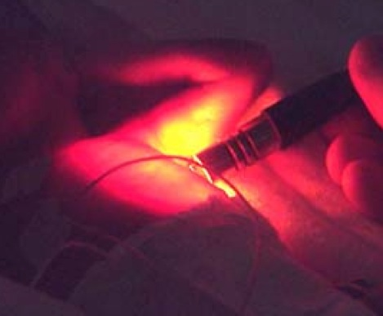

Transilluminating the chest – the whole hemithorax “lights up” in the presence of a pneumothorax

**Optimising mechanics**

**Inspiratory time (Ti)**

Babies generally require shorter inspiratory times than older children. This is particularly the case for preterm infants in the first few days of life (typical Ti 0.35 seconds). The Ti a baby requires can be deduced from the ventilator display.

Longer Ti times may hold the chest open longer than is comfortable for the baby, the baby may then attempt to breathe out against inspiratory flow. If you see this pattern you may want to consider reducing Ti

PIP delivered for period of Ti but no flow (red) or increase in volume (green) after initial rise

Ti

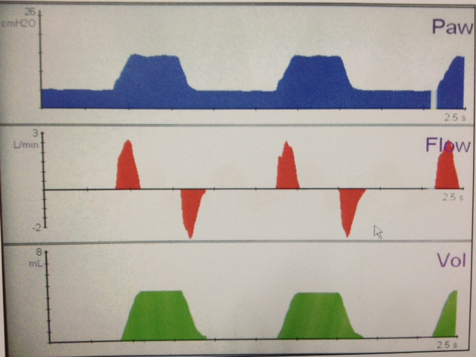

Long gap between flow in and flow out – lung is being held open

However Ti does need to be long enough to allow the ventilator to deliver the required breath. Bigger babies and babies with chronic lung disease may require longer Ti times to open up the lung and allow the necessary volume to be delivered. A too short Ti may prevent the ventilator delivering the tidal volume required which can affect both oxygenation and ventilation.

Ti

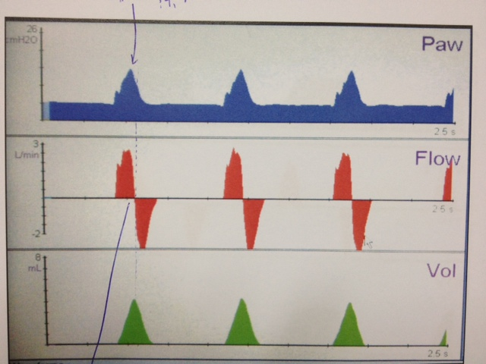

Pressure increases but does not reach plateau

Flow into the lung suddenly reversed with no gap between inspiration and expiration

This pattern suggests this baby would benefit from a longer Ti time.

**Expiratory time (Te)**

Just as we need to make sure enough gas is getting in, we also need make sure the expiratory phase is long enough to allow gas out.

As a rule Te should be at least as long as Ti (not usually an issue unless high rates with longer Ti)

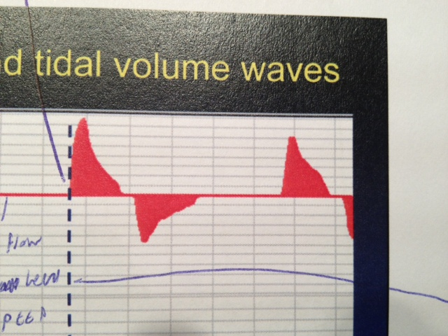

Should see a gap between end of expiratory flow and start of next breath

**Optimising mechanics**

**Slope / flow**

You can adjust the time taken for the ventilator breath to reach it’s maximum inspiratory pressure by adjusting the speed of the gas flow through the ventilator

Drager choose to describe this as **“slope”** – expressed as the time taken to reach the required Pinsp (in seconds)

Increased flow (or shorter “slope” time) leads to a “squarer” wave where pressure rises rapidly. A higher flow causes a rapid inflation of the lung and is potentially more uncomfortable for the baby and perhaps more damaging in the long-term.

High flows are sometimes desirable as it will increase the mean airway pressure (area under the curve) and thus lead to some improvement in oxygenation.

A low flow (longer “slope” time) gives a gentler change in pressure.

However if this is set too low it may mean the ventilator breath runs out of time (Ti) and is unable to deliver the set pressure or volume.

In practice we usually leave “slope” (flow) at a default of **0.08** seconds.

It should always be less than Ti

**Auto-trigger**

Water in the circuit can trigger the flow sensor to initiate ventilation breaths.

This is often seen as a noisy or messy display and can interfere with effective ventilation.

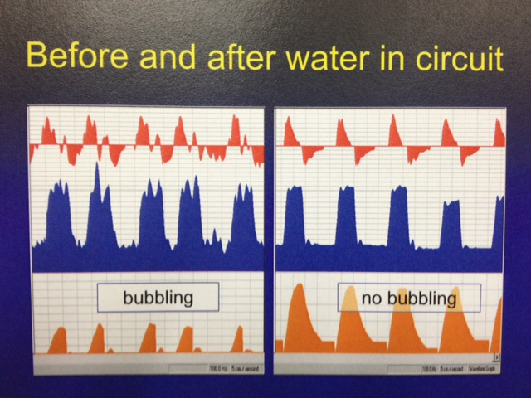

If you see this – check the circuit for water / moisture and briefly disconnect to allow it to drain out.

Moisture on the flow sensor or problems with calibration can sometimes cause the ventilator to misinterpret expiratory flow as inspiratory flow.

High Pressure hitting top limit

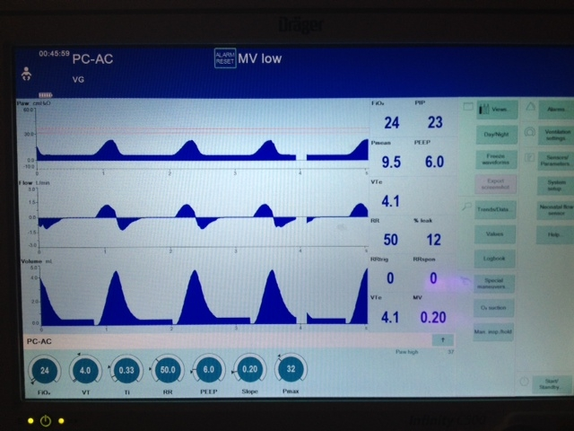This is a particular

problem in VG mode where the

ventilator fails to recognise an expired

VT and ramps up the pressure to

try and compensate.

If you see this then look for

Initial inspiratory flow then apparent additional inspiratory flow straight after

moisture around the sensor and recalibrate (see below).

Try to position the flow sensor “pointing down”,

with the connecting lead coming in vertically.

**Back-up rate**

A set respiratory rate of 55-60 may be required for a baby with inadequate spontaneous respiratory effort due to sedation or muscle relaxant.

However it is quite common to find spontaneously breathing babies with a back-up rate set at around 60. Whilst it is true that reducing rate in PC-AC mode is pointless in terms of weaning, back-up rates set near to a baby’s own spontaneous breathing rate can affect synchronisation and do not allow you to get a clear idea about respiratory drive.

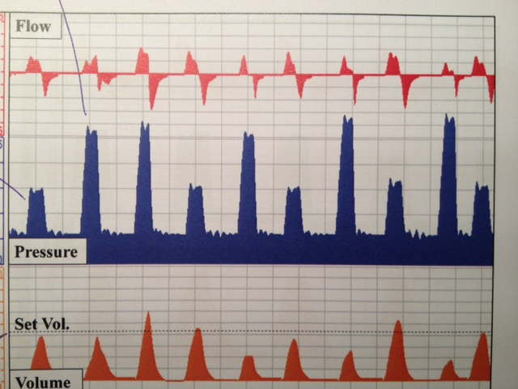

Ventilation breaths

Triggered breaths – require less pressure to achieve set volume

The back-up rate in this baby is likely to be set at around the baby’s own respiratory rate and is overriding the baby’s own respiratory effort – it can probably be reduced

In spontaneously breathing babies on PC-AC, consider dropping the rate to 30-40. However you will need to watch to see if the MV changes significantly due to this and repeat a gas 30 minutes later.

**Alarms**

It is too easy to get into the habit of ignoring or silencing alarms. This can be dangerous. Try to work out what the ventilator is trying to tell you

**Flow sensor**

The flow sensor may need calibration – it needs to be working effectively to allow synchronisation and measurement of tidal volume - follow the onscreen instructions to recalibrate.

VG mode will not work properly if the flow sensor is not functioning.

The sensor is just a thin wire and can be damaged. It can also be upset by moisture – this problem can sometimes be reduced by having the flow sensor “pointing down”, with the connecting lead coming in vertically.

**High respiratory rate / High MV**

Is there water in the circuit causing an auto-trigger effect?

Has the baby “woken up” and is now triggering more breaths than previously – you may need to check a gas to check the baby isn’t now over-ventilated? Can the baby be extubated?

**Low tidal volume / Low MV**

In VG mode this is often because the top limit PIP is set too low. The ventilator may then not be allowed to generate the pressured require to deliver the volume you have asked it too. It is common for PIP requirements to fluctuate to quite large degrees in order to maintain a consistent VT – consider increasing the PIP limit or, if clinically appropriate, reducing the VT.

However if there is a sudden or marked change in PIP requirements or loss of VT then consider other causes – tube obstruction (secretions etc) or displacement.

**Apnoea**

This alarm sounds if there is no flow at all through the circuit. Sometimes babies splint their diaphragm (often for reasons unknown) but this should only be temporary. Check if the tube is blocked.

**Leak**

It is normal for there to be some leak around the ET tube – neonatal tubes are uncuffed. However large leaks can cause problems as lots of air escaping from the circuit reduces the accuracy of tidal volume measurement.



Leak – volume curve doesn’t return to zero

This is a particular problem in VG mode.

PIP may increase as the ventilator seeks to compensate for what it perceives as a reduced Tidal Volume flowing back across the flow sensor

The ventilator can compensate to a degree (particularly if the Leak compensation feature is activated) but with a leak of >50-60% it is safer to turn off VG and use a Pressure adjusted mode.

Very large leaks can lead to ineffective ventilation and may necessitate tube change

If there is a sudden increase in leak then consider whether the tube may have become displaced, or in some cases whether a pneumothorax is present.

1. **HFOV**

High frequency oscillatory ventilation (HFOV) is a different approach to achieving gas exchange.

Rather than the inspiratory / expiratory pattern we have seen so far, HFOV acts by holding the lung open and using alternative ways to move O2 and CO2 in and out.

Theoretically it is advantageous in that it avoids the cyclical overdistension / derecruitment that can occur with standard modes of ventilation.

**“CPAP with a wobble”**

We saw before that **Oxygenation** depends on the Mean Airway Pressure (MAP) and the inspired oxygen (FiO2).

It is not very reliant on tidal volume - gas being moved in or out.

As long as a lung is open, oxygen will diffuse down a gradient from the O2 supplied by the ventilator to the alveoli

HFOV oxygenates by applying a constant pressure – the MAP, adjusted to maximise recruitment of lung volume.

Pressure

MAP

Time

Upto a point an increase in the Mean Airway Pressure opens up more and more of the lung and allows greater oxygenation.

Increasing the FiO2 increases the gradient of diffusion and also improves oxygenation

However some gas movement is still required, particularly for **clearance of CO2**.

HFOV does this by moving small volumes of gas back and forth (Oscillation) at very high frequency – the “wobble”.

This means the lungs do not inflate / deflate with each ventilator breath, instead the high amplitude oscillation creates complex flow patterns that allows CO2 to be cleared from the alveoli whilst still being held open.

Pressure

Time

Small volumes of gas moved back and forth at high frequency

**Oscillation**

The amplitude and frequency of this Oscillation, determine the amount of CO2 clearance.

An increase in amplitude (termed delta P or P) increases CO2 clearance (lowers pCO2)

- analogous to changes in VT in standard ventilation -

A **decrease** in frequency (Hz) increases CO2 clearance (lowers pCO2)

As small changes in frequency can lead to big shifts in CO2, We would usually **adjust the amplitude** (or wobble) rather than the frequency.

This all may seem complicated at first but it does mean that CO2 clearance and Oxygenation can be manipulated separately with HFOV, and, once you are used to it, making changes is actually more straightforward.

|  |  |  |  |
| --- | --- | --- | --- |
| Poor Oxygenation | Over Oxygenation | Under Ventilation | Over Ventilation |
| Increase FiO2 | Decrease FiO2 | Increase Amplitude | Decrease Amplitude |
| Increase MAP (1-2cmH2O) | Decrease MAP (1-2cmH2O) | Decrease Frequency  (1-2Hz) if Amplitude Maximal | Increase Frequency  (1-2Hz) if Amplitude Minimal |

**HFOV indications and use**

We tend to use HFOV as a rescue therapy in severe lung disease.

Consider if a baby is requiring persistently high pressures, high FiO2, rising OI (see below). Discuss with consultant before starting.

* + Failure of conventional ventilation in a term infant (i.e. with PPHN or MAS)
  + Failure of conventional ventilation in the preterm infant (severe RDS, PIE, pulmonary hypoplasia) or to reduce barotrauma when conventional ventilator settings are high.

The **Drager** ventilator can be easily switched to HFOV without disconnecting the baby from the ventilator.

In some bigger babies who are very poorly, we might consider using the **Sensor-medics** oscillator.

**Starting settings**

* + Set **MAP** 2-3 cmH2O above the MAP on conventional ventilation
  + Set **frequency** at 8-10 Hz
  + Set **Delta P** (amplitude) at level that gives a good chest “wobble”
    - It is hard to give a figure for this as it will vary depending on the patient

HFOV is often very effective at reducing CO2 so an **early gas** is mandatory (<30mins)

It’s possible to get the Drager ventilator to set the Delta P for you by using **HFOV + VG**

* + With this mode a VT of 2ml/kg is selected and the machine will deliver an amplitude that achieves this.
  + However this does not guarantee a “normal” CO2 and you will still need to check an early gas

**Effective HFOV**

Achieving and maintaining optimal lung inflation is the key to HFOV success. This can be difficult.

Lung recruitment may take time. Try and avoid breaking into the circuit (e.g for suction) unless this is absolutely necessary.

The aim is to open up the lungs to maximise recruitment and avoid atelectasis. However over-distension risks barotrauma, air-leak and obstruction of venous return to the heart (leading to cardiovascular compromise).

Make small changes and review regularly. Observe the effect of your changes on oxygen saturation, BP and acid/base balance. Arterial access for continuous BP monitoring and sampling should be obtained.

An early **Chest X-ray** is important to look at the degree of lung expansion – you should aim for 8-9 ribs (posteriorly). Further Chest X-rays should be performed if there are changes in status.

**Effective HFOV**

Optimal inflation can be illustrated in this Pressure / Volume loop

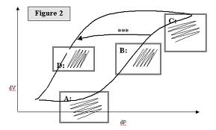

Volume

Pressure

<http://www.sswahs.nsw.gov.au/rpa/neonatal/html/newprot/hfov.html>

**Point A in figure: Under-inflation:** A relatively large amplitude will produce only small changes in volume. Clinically this manifests as a high oxygen requirement with limited chest vibration/wobble.

**Point B: Optimal recruitment inflation:** Once the lung has opened up with higher MAP, a smaller amplitude will produce a larger change in volume. Clinically this manifests as falling oxygen requirements and good chest vibration/wobble.

**Point C: Over-inflation:** Again more amplitude will be needed to produce volume changes and over inflated lung will compromise the systemic circulation. This is the most dangerous point in HFOV and is to be avoided at all costs. It is difficult to pick clinically because the oxygen requirement stays low, although they will eventually rise and the reduced chest vibration is easy to miss.

Chest X-ray is currently the best diagnostic tool for this see below.

**Point D: Optimal inflation**: The goal should be to move the babies

lungs from point B to point D avoiding point C (as shown on the arrow marked ***

in Figure 2). Having achieved optimal lung inflation by slowly reducing the MAP it

should be possible to maintain the same lung inflation and ventilation at a lower

MAP. If MAP is lowered too far oxygen requirements will start to rise.

**Oxygenation Index (OI)**

Oxygenation Index provides a ratio between the level of oxygen being delivered to the lungs and the amount diffusing into the blood. As such, it represents the ability of the lungs to diffuse oxygen across the alveolar membranes and may be useful in conditions affecting pulmonary function.

Oxygenation Index = FiO2 x 100 x Mean Airway Pressure (cm H2O)

PaO2 (kPa) x 7.5

FiO2 is the inspired oxygen fraction – e.g. 21% = 0.21, 100% = 1.0

  kPA x 7.5 converts to the equivalent PaO2 in mmHg

OI calculator link (converts PaO2 from kPA to mmHg for you)

<http://www.neoweb.org.uk/Additions/oxygenation_index.htm>

**Updated from previous BRI guideline**

**Additional material adapted from -**

1. Drager product literature and educational material
2. Auckland District Health Board Neonatal Guidelines. <http://www.adhb.govt.nz/newborn/teachingresources/ventilation/ventilationbasics.htm>
3. Leeds Neonatal Handbook
4. Sydney South West Area Health Service Neonatal Guidelines

<http://www.sswahs.nsw.gov.au/rpa/neonatal/protocols.html>

1. Specialist neonatal respiratory care for babies born preterm (NG124) <https://www.nice.org.uk/guidance/ng124>