

Title: Insertion of Umbilical Lines in Neonates

Authors: Catriona Firth, Chakra Vasudevan, Carol Hudson

Approved by: Neonatal Guideline Group 23/07/2018

Updated 04/05/2021

Minor addition on 12/04/2022

Review date: 04/05/2026

Version: 8

**Umbilical lines** are frequently needed for infants in intensive care.

An umbilical arterial catheter (UAC) allows for frequent blood gas monitoring and blood sampling, invasive central blood pressure monitoring, and can be useful for procedures such as exchange transfusions. In exceptional circumstances a UAC can be used for infusion of clear fluids (ie when no other access is available).

An umbilical venous catheter (UVC) allows initial central access for TPN, inotropes and hyperosmolar solutions, and for procedures such as exchange transfusions.

**Aims:**

A **UAC** should lie within the aorta, avoiding the location of any major branches, having taken a course through either of the umbilical arteries into the left or right internal iliac artery, iliac artery and into the aorta (see Figure 1). An umbilical catheter will therefore always go down towards the pelvis before turning up into the iliac vessels. The ideal final position is between T6 and T10.

Figure 1: Demonstration of arterial anatomy and ideal UAC placement

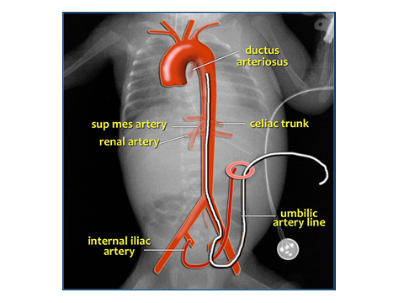

NB this figure demonstrates the anatomy pictorially and does not adequately represent the usual downward path towards the pelvis, before turning cephalically (this is better demonstrated on the x-ray below – Figure 4).

A **UVC** tip should lie at the junction of the IVC and the right atrium. The catheter takes a course through the umbilical vein, the central part of the left portal vein and the ductus venosus to reach the IVC (see Figure 2). On a radiograph this corresponds to the tip being at the level of the diaphragm or slightly above (usually T8-T9 – see Figure 4).

Figure 2: Demonstration of venous anatomy and ideal UVC placement

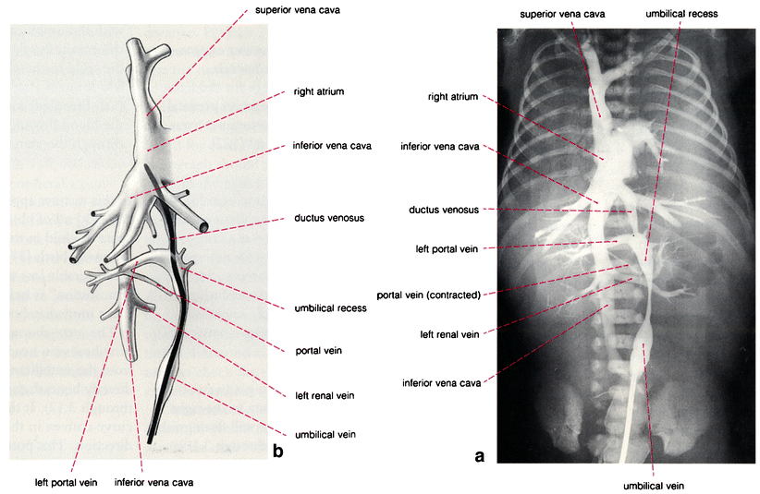

**Calculations and Catheter Choice**

Before commencing the procedure, calculate the correct catheter length using the following formulae – **do not** forget to then add the length of the umbilical stump!

* UAC= (weight x 3)+9 = length in cm (+stump)
* UVC= (weight x 1.5)+5.5 = length in cm (+stump)

Or,

* UVC **=** (half the UAC distance) +1 = length in cm (+stump)

Catheter choice:

* UVC –use a double lumen 4Fr catheter
* UAC –use a single lumen catheter 3.5Fr for <1.5kg and 5Fr for >1.5kg.

**Procedure:**

Maintain strict asepsis throughout – see “Aseptic technique for central lines

Before insertion, the CVC checklist needs to be commenced and should be completed by an observer (nurse or doctor) contemporaneously and recorded in the notes. If you are not able to have an observer present throughout, this should be documented. The CVC checklist is regularly audited for IPC purposes and is an important document to assess asepsis during the procedure.

**Top Tips for Safe and Successful Insertion**

1. Flushing:

* Pre-flush lines with heparinised saline (1 unit/ml) – use a separate syringe for each line
* Ensuring no air bubbles throughout, attach a pre-flushed 3 way tap to the UAC and pre-flushed smart sites to each lumen of the UVC.

1. Cutting:

* Apply cord tie at the base loosely which can be easily tightened if any bleeding occurs.
* Use forceps or artery forceps to hold the cord and transect approximately 1cm above abdominal wall
* Aim to achieve a straight “clean cut” using one steady motion of the scalpel

1. Identifying:

* Veins are thin walled with a larger lumen
* Arteries have thicker walls, smaller lumens and tend to “stand proud.”

1. Stabilising:

* Use artery forceps to stabilise the cord
* Gentle upwards traction can help when dilating the vessels and inserting lines

1. Dilating:

* Be patient when dilating the arterial lumen (the vein doesn’t usually need dilating)
* Use the blunt dilator and non-toothed artery forceps to dilate the arterial opening
* Do not push the dilator further down the vessel – you will cause a false passage

1. Inserting:

UAC:

* Some resistance may be felt when inserting the UAC
* Pulling the umbilicus cephalically can help negotiate the curve of the artery’s path
* If unsuccessful ask a senior before attempting the 2nd vessel. A lateral arteriotomy may be helpful.

UVC:

* A UVC should be easy to advance
* If resistance is felt before or at the target length, the catheter may have entered the portal system – withdraw by a few cms and re-advance with a clockwise twisting motion

1. Checking:

* Both types of lines should bleed back and flush easily in their final positions

1. Fixing:

* See picture and notes below (Figure 3)
* The umbilical lines need to fixed in a way that minimises movement, provides easy visibility to ensure ongoing assessment of position and enables easy adjustment if needed. The tape needs to be applied close to the cord with the sutures taut.
* Tie an additional vicryl suture around the umbilical cord and tie in a double knot aith the aim of preventing bleeding (see figure 3)

1. X-raying:

* Ensure equipment (instruments, ECG leads, transwarmers etc) are removed prior to x-ray
* Check line positions carefully (see below)
* Document position in notes using the CVC checklist

1. Tidying:

* Return all the instruments to the cleaning room with the A4 sheet of paper (checklist)
* Put one sticky label in the notes, one on the return sheet in the cleaning room and the large label stays with the instruments.

Figure 3: Fixing of lines

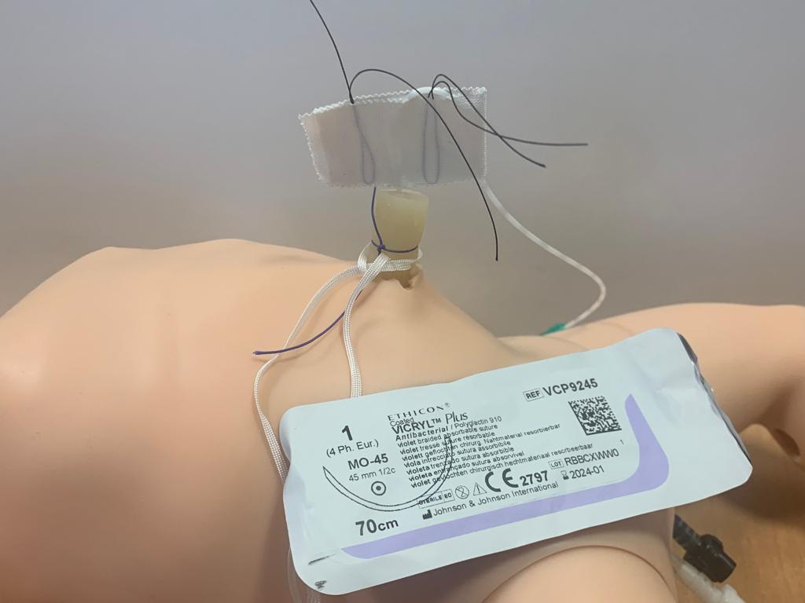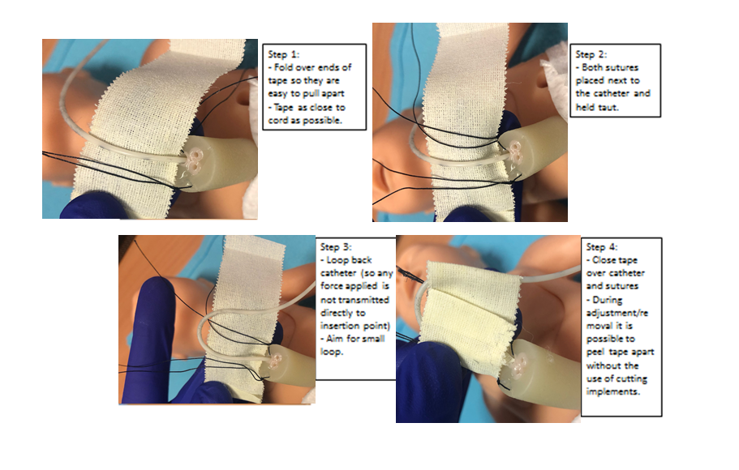

**Confirmation of Line Positions**

Figure 4: Acceptable UVC and UAC positions



N.B The red area indicates satisfactory UAC position, the blue area satisfactory UVC position. The adjacent radiograph shows a correctly positioned UAC at T10 (see downward path before turning upwards), and a correctly positioned UVC at T8-9.

A UAC should:

* Take a path towards the pelvis before turning upwards
* Lie between T6 and T10 (thus avoiding the coeliac artery (T12), superior mesenteric artery (T12-L1) and renal arteries (L1)).

A UAC should not:

* Lie below the level of the aortic bifurcation (due to the risk of thrombosis to the lower limbs).

A UVC should:

* Take a straight path
* Lie between T8 and T9, and not below T10
* Lie outside of the cardiac silhouette.

A UVC should not:

* Lie over the heart or liver (to minimise the risk of cardiac tamponade or extravasation injury to the liver)
* Turn or kink – this suggests it has taken the wrong path

A UVC can:

* Be used in a low-lying position for a short period of time but be replaced at the earliest opportunity (at the discretion of the consultant).

Following assessment of x-ray:

* A line which is lying too high can be pulled back (use tools on x-ray to measure distance to pull back). Ensure that the line tip is well outside the heart by repeating the Xray once / if line is repositioned.
* A line which is too low should never be advanced due to the risk of introducing infection
* Opportunistic review of line positions should occur with any subsequent x-rays
* Any alteration of a line position should be documented. All line positions need to be reviewed by a consultant (at an earliest possible opportunity) and signed off on the checklist

Post procedure care

1. Ensure that the line is visible and not covered by the nappy to enable early detection of bleeding (Nappies can absorb large amounts of blood and hence bleeding may not be apparent early if umbilical lines are covered)
2. Regular checks to identify any bleeding by visual inspection (at least every half hour for the first two hours post insertion) and documented in the CVC insertion checklist.
3. Babies should be nursed supine for at least 12 – 24 hours post insertion

**Duration:**

The need for a UAC should be reviewed daily. The line is no longer needed once ventilation and blood pressure have stabilised, and the need for frequent blood testing and invasive blood pressure monitoring is reduced. In extreme preterm infants the line may be left for longer to limit skin damage from peripheral blood tests.

The need for a UVC should be reviewed at 5 days. If the baby is likely to need central access beyond a week of age, a long line should be inserted and the UVC removed. If the baby is approaching full feeds, the UVC can remain in situ, but for no longer than 7 days in total, unless that decision is made by a consultant.

**Potential Complications:**

**UAC**

|  |  |
| --- | --- |
| Complication | Details |
| Infection | Common. Minimise risk by use of strict asepsis and removal of line once no longer needed. |
| Haemorrhage | Can occur during insertion, removal, or if line becomes dislodged. Treatment includes haemostasis (consider use of surgical) and transfusion. |
| Ischaemia | Can occur to lower limbs and perineum. A fluid bolus can improve perfusion but if concern persists the catheter should be removed. |
| Thrombosis | Common (between 1.5 and 95% of catheters depending on method of detection). Majority are asymptomatic and do not require treatment. Symptomatic or persistent thrombosis may require treatment (see above for UVC). |
| Urachal cannulation | This is seen if urachal remnant is mistaken for an artery. Treatment is surgical intervention. |
| Hypertension | This is likely related to renal artery thrombosis (partial/total). This should be managed symptomatically unless the artery thrombosis requires therapy. |

**UVC**

|  |  |
| --- | --- |
| **Complication** | **Details** |
| Infection | Common. Minimise risk by use of strict asepsis and removal of line once no longer needed. |
| Thrombosis | Seen in approximately 11% with lines. Anti-coagulation and line removal (after 3-5 days of anti-coagulation to minimise risk of paradoxical emboli) recommended but to discuss with haematology on case by case basis. |
| Bleeding | Small amounts of oozing is common but this needs regular monitoring. Any concerns should be escalated and addressed with appropriate haemostatic interventions (tightening cord tie, further sutures if needed) |
| Cardiac Tamponade | Rare. Can occur with correctly positioned lines and should be considered in any patient with a central ilne who undergoes unexplained cardiorespiratory collapse. Diagnose with echo if expertise available. Treat with emergency cardiac paracentesis. |
| Hepatic capsular injury | Can occur in correctly placed catheters following difficult insertion (which may represent misplaced attempts). Can present as cardiovascular collapse, abdominal distension or unexplained anaemia. Diagnosis with ultrasound. Treatment symptomatic with correction of anaemia and coagulopathy. Even with prompt diagnosis and management can be fatal. |
| Hepatic parenchymal injury | This can follow infusion of hyperosmolar solutions via misplaced catheter and may lead to necrosis of parenchyma, or extravasation leading to ascites. Treatment is symptomatic, with removal of the catheter. |

**Evidence Base: References**

1. The use of central venous catheters in neonates. A framework for practice. British Association of Perinatal Medicine. 2015.
2. Umbilical venous and arterial lines – indications, insertion, use and care of. Yorkshire and the Humber ODN Clinical Guideline. Reviewed 2016.
3. A.Oestreich (2010) Umbilical venous catheterization: appropriate and inappropriate placement. *Pediatric Radiology* **40**(12):1941-1949.
4. Van Schuppen et al (2013) Lines and tubes in neonates. Radiology Assistant (available at <http://www.radiologyassistant.nl/en/p526bd2e468b8c/lines-and-tubes-in-neonates.html>).
5. Umbilical artery and vein catheterization. Auckland District Health Board Clinical Guidelines. 2013.